PLANT DEFENSES IN THE CLOUD FOREST
Station Slips
Name:
Name of Station/Plant: | Problem Faced by Plant: | Method of Defense:

Name:
Name of Station/Plant: | Problem Faced by Plant: | Method of Defense:

Name:
Name of Station/Plant: | Problem Faced by Plant: | Method of Defense:

Name:
Name of Station/Plant: | Problem Faced by Plant: | Method of Defense:

Name:
Name of Station/Plant: | Problem Faced by Plant: | Method of Defense:

Name:
Name of Station/Plant: | Problem Faced by Plant: | Method of Defense:
PLANT DEFENSES IN THE CLOUD FOREST
Group Presentation Preparation

Name of our defense mechanism:

How can I explain this defense mechanism?

Examples of plants that use this defense mechanism and why:

Incorrect examples placed in my box:

Name of our defense mechanism:

How can I explain this defense mechanism?

Examples of plants that use this defense mechanism and why:

Incorrect examples placed in my box:

PLANT DEFENSES IN THE CLOUD FOREST
Student Assessment: Defense Mechanisms

◻ 2 points Correct, clear, and thorough  ◻ 1 point Partially correct and clear  ◻ 0 points Incorrect or unclear | #1 | List three defense mechanisms used by plants:
◻ 2 points Correct, clear, and thorough  ◻ 1 point Partially correct and clear  ◻ 0 points Incorrect or unclear | #2 | Define thigmonasty and give an example of a plant that uses this mechanism.
◻ 2 points Correct, clear, and thorough  ◻ 1 point Partially correct and clear  ◻ 0 points Incorrect or unclear | #3 | Read the following description and determine the type of defense mechanism used by the plant: Lithops spp. lives in very dry regions of southern Africa. These plants avoid being eaten by blending in with surrounding rocks. They are more commonly referred to as “pebble plants” or “living stones”.
◻ 2 points Correct, clear, and thorough  ◻ 1 point Partially correct and clear  ◻ 0 points Incorrect or unclear | #4 | Examine the picture from the Mid Elevation Forest and determine the type of defense mechanism displayed. Explain the problem this plant is facing and why it needed to defend itself in this manner.  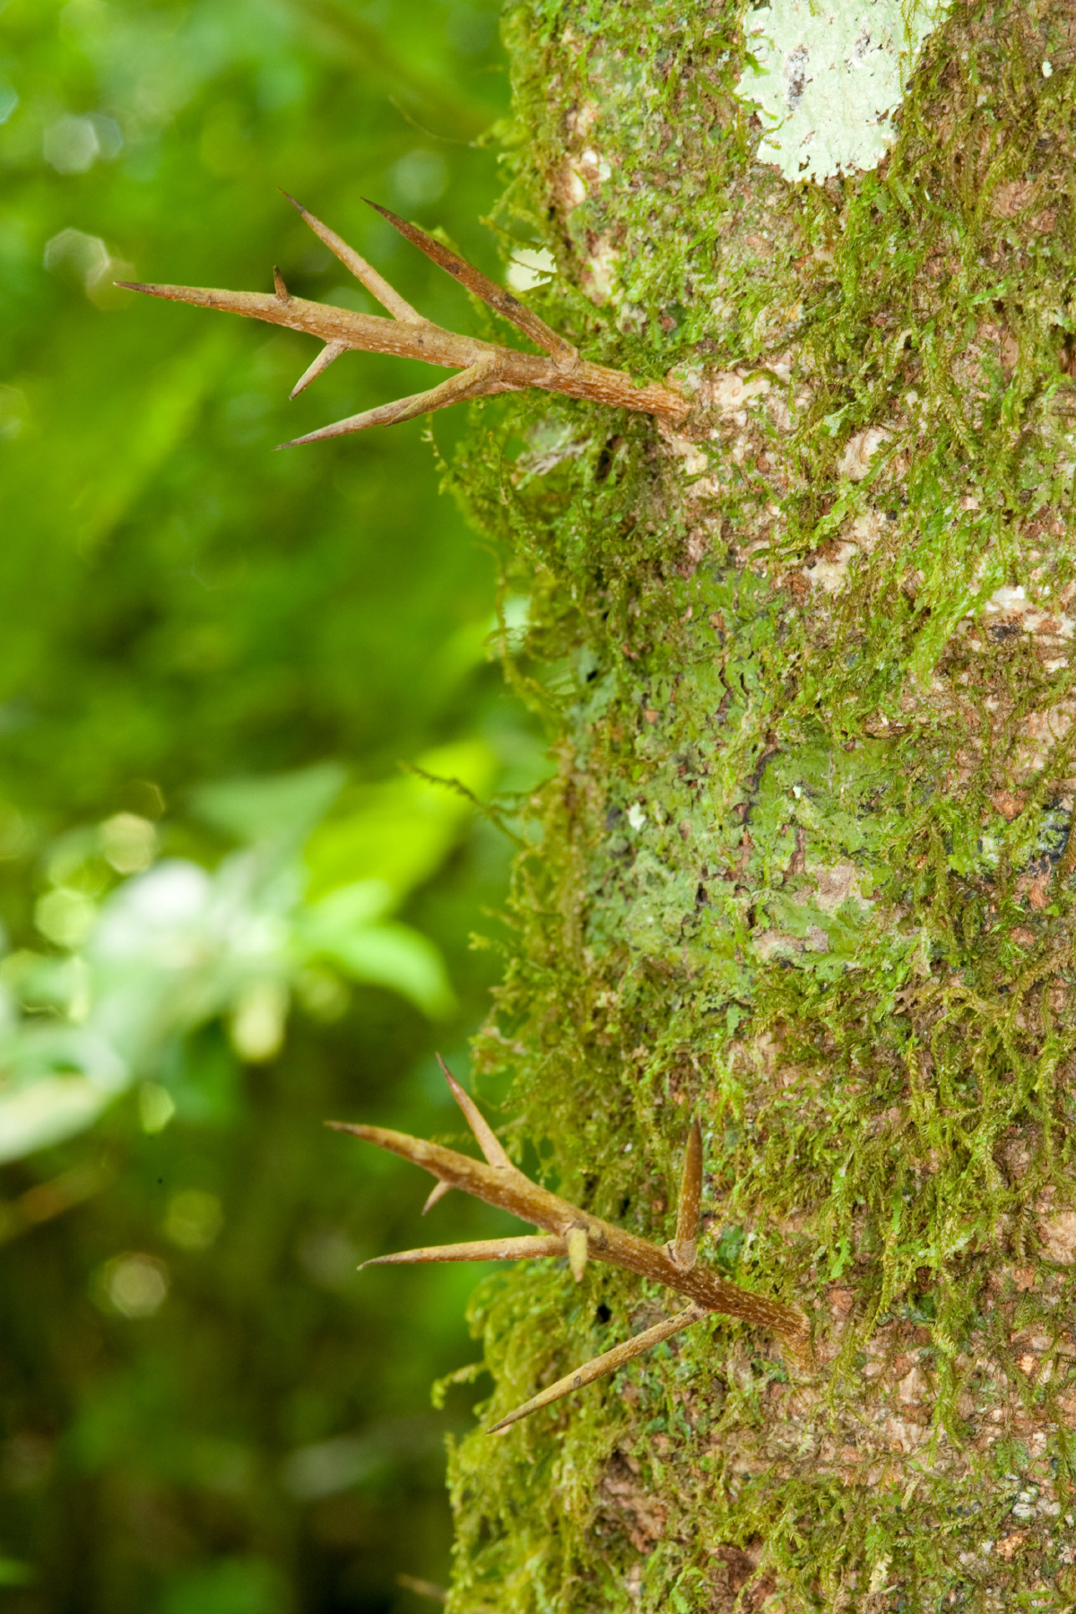
◻ 2 points Correct, clear, and thorough  ◻ 1 point Partially correct and clear  ◻ 0 points Incorrect or unclear | #5 | A species of leguminous plant grows readily in a large meadowland. The population of white-tailed deer in the area is high. Develop a defense mechanism that this plant could evolve to protect itself from deer predation. Be sure to include the type of defense mechanism it is, as well as a thorough explanation.
- 10 points | Mastery – You have a strong understanding of the lesson objectives.
- 8 – 9 points | Proficient - You’re almost there!
- 6 – 7 points | Beginning Proficiency – You are starting to understand.
- 1 - 5 points | Needs Improvement – You made several mistakes. Ask for help and keep practicing.
Total Score = ______ / 10

PLANT DEFENSES IN THE CLOUD FOREST
Plant Lists

Defense Mechanism | Description | Plant Examples
Chemical | Influences the behavior, growth, or survival of herbivores. May act as repellents, toxins, or reduce plant digestibility. | Panorama #2 hotspot “Fuzzy Leaves”  Video “Tree Sap”  poison ivy, oak, and sumac, many types of unripe fruit  sap
Mechanical | External structural anatomy that discourages herbivore predation. May deter, injure, or kill herbivore. | Panorama #1 hotspots “Why Spines” and “Science of Leaf Toughness”  Panorama #2 hotspot “Fuzzy Leaves”  sap, spines, layers of armor around seeds, rose thorns, raspberry plants, coconuts,
Thigmonasty | Movement in response to touch. | Mimosa
Mimicry & Camouflage | Acts or looks like another organism. | passion flowers or passion vines, mistletoe

