MEASURING LIGHT IN THE CLOUD FOREST
Quantity of Light and Plant Growth

Observations
Watch the two Canopy In The Clouds videos presented by your teacher. Listen to the scientist and record the amount of sunlight reaching each location within the cloud forest. Record your findings below.

Mid elevation forest understory: _________________________

Mid elevation forest canopy: ____________________________

Scientific Question
How does the amount of sunlight available affect plant growth in the cloud forest?

Hypothesis
Based on your observations, write a hypothesis for the scientific question. Remember to use the form “I predict…..because….”.

Procedure
- Get a clear measurement square from your teacher.
- Go to the mid elevation forest understory (Panorama #2) and select the Natural Scene. Record the total units of sunlight available, as seen in your observations.
- Randomly select ten locations within the understory to place the measurement square on. **Avoid locations that include large amounts of sky or large tree trunks that are close proximity. You may use locations on the ground.**
- At each location, determine the percentage of your square that is covered in green plant growth. Your entire measurement square represents 100%. It has been divided into four smaller squares (25% each) to help your estimations.
**Epiphytes growing on tree trunks count as green plant growth, but bare tree trunks do not.**
- Record your data in the data table under “My Group”.
- Once you have collected ten data pieces, share data with other groups. Write their data in the columns labeled “Group #1”, “Group #2” and “Group #3”.
- Calculate the average of all the data pieces.
- Repeat procedure steps 1-7 for the mid elevation forest canopy.

Data Table

Data # | Percent Filled with Green Plant Growth
Data # | Mid Elevation Understory |  |  |  | Mid Elevation Canopy
Data # | Units of sunlight: ___________ |  |  |  | Units of sunlight: ___________
Data # | My Group | Group #1 | Group #2 | Group #3 | My Group | Group #1 | Group #2 | Group #3
1
2
3
4
5
6
7
8
9
10
Sum of each group
Sum of all groups
Average

Graph

Create your graph below. Don’t forget to include:
- Title & Legend
- Locations along x-axis
- Evenly spaced percentage increments along y-axis
- Labels

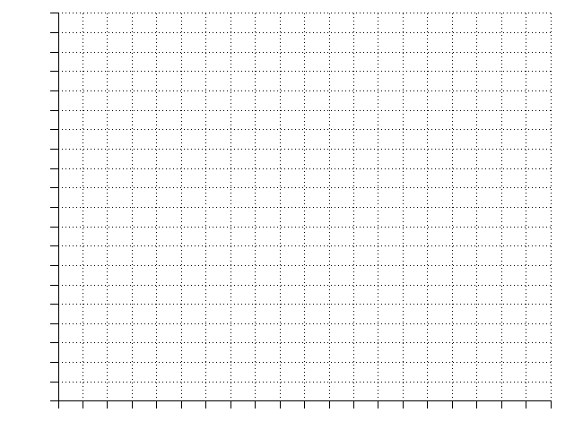

Conclusion

Part 1 → Mid Elevation Forest
Using the data you have collected, write a conclusion that answers the scientific question. Discuss whether or not your hypothesis was supported, and your reasoning.

Part 2 → Light Gap (complete when instructed by your teacher)
Now that you have collected three sets of data, answer the questions below.

- Using previous data collected, write a hypothesis for the quantity of sunlight in the light gap. I predict that the light gap has…. units of sunlight because…….
- How is the light gap location similar to or different from the mid elevation location of the cloud forest?
- What is the role of sunlight in the cloud forest ecosystem? Why is it important?

MEASURING LIGHT IN THE CLOUD FOREST
Light Gap

1) Describe what a light gap is and how it forms.

2) Using the same procedure from the mid elevation forest, collect data from the light gap (Panorama #7, Natural Scene).

Data # | Percent Filled with Green Plant Growth
Data # | Light Gap
Data # | My Group | Group #1 | Group #2 | Group #3
1
2
3
4
5
6
7
8
9
10
Sum of each group
Sum of all groups
Average

3) Add the data collected from the light gap to your graph.
4) Answer the questions given by your teacher in your conclusion.
MEASURING LIGHT IN THE CLOUD FOREST
Measurement Squares

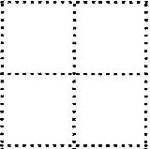

MEASURING LIGHT IN THE CLOUD FOREST
Student Assessment ~ High Elevation Site

Directions:
- Examine the photograph of the understory below. This was taken at the high elevation site within the cloud forest.
- Use your measurement square to determine the percent of plant growth in five different locations on the photograph. Calculate the average.
- Using the data you collected regarding the sunlight available in the mid elevation site and the plant growth data, as well as the plant growth data from the light gap, answer the questions given.

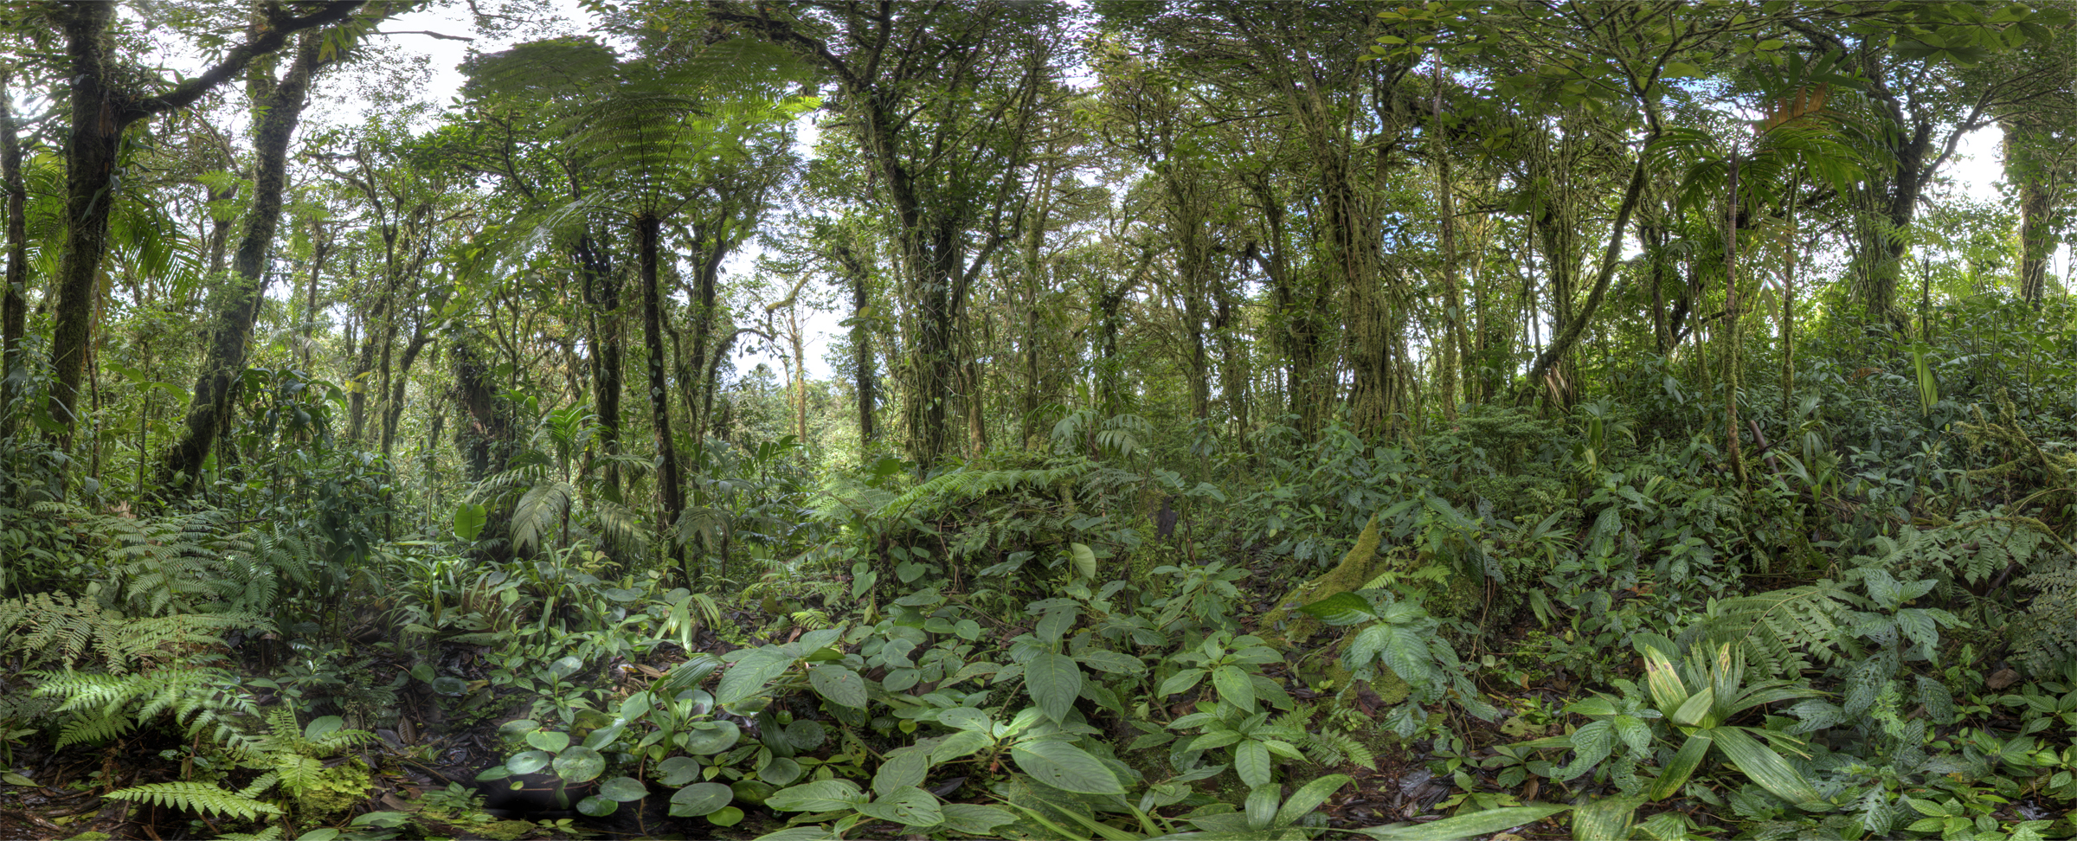

Data Table

Data # | Percent Filled with Green Plant Growth
Data # | High Elevation Forest Understory
1

2

3

4

5

Sum

Average

- Based on the data you collected, how many units of sunlight do you believe are penetrating the understory of the high elevation forest site? Explain your answer.

- How does the understory of the high elevation site compare with the understory of the mid elevation site?

- How does the understory of the high elevation site compare with the light gap?

- What other factors contribute to the growth of plants in forest ecosystems?

