MICROHABITATS: THE HABITAT OF THE ROTTING LOG
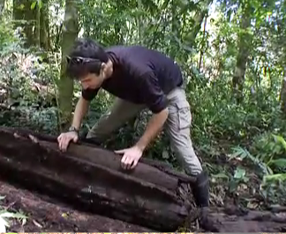
What do taiga, tundra, desert, salt water, fresh water, prairie, and forest areas have in common? They are all habitats in which plants and animals live. Within these habitats are smaller, often overlooked areas called microhabitats. A microhabitat area has unique conditions and is populated with a certain set of organisms. In an ocean, you might find a microhabitat within a coral reef. In a desert, a lone cactus can be a microhabitat. Within a forest, each tree hole is a microhabitat and each rotting log exists as its own microhabitat. Once you start paying attention to microhabitats, you can discover them almost anywhere!
Microhabitats in the Cloud Forest
Let’s begin by exploring the cloud forests of Monteverde, Costa Rica, where microhabitats abound. First, go to Panorama 2 (mid-elevation forest), stay on the ground, and watch video #5.

List all of the organisms that live in the microhabitat of this rotting log.
__________________________________________________________________________________________________________________________________________________________________________________________________________________________________________________

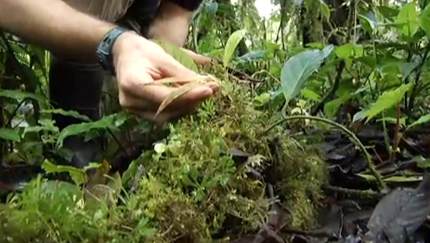
Your next stop is Panorama 3 (high elevation forest). Remain on the ground and watch video #5.

How does this fallen branch compare to the rotting log that you saw in the previous panorama? Give at least two similarities and two differences between the two.
__________________________________________________________________________________________________________________________________________________________________________________________________________________________________________
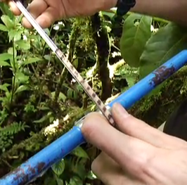
Soon you are going to examine a rotting log first hand. Before you do so, it will be helpful to know a bit about tree rings and what they can tell us about a tree’s history. Go to Panorama 5 (Atlantic slope), stay on the ground (that’s your only option here anyway!) and watch video #3.

What is a tree core sample?
________________________________________________________________________________________________

What is a growth ring?
____________________________________________________________________________________________________________________________________________________________

What sorts of data can be interpreted from core samples?
____________________________________________________________________________________________________________________________________________________________

Microhabitats in Your Local Environment
You do not need to live in a tropical forest to explore microhabitats first hand. In fact, today you will examine a rotting log from your local environment.
Locate a rotting log (or several) near your school. Your teacher may have already found some for the class to use. When you find one, crouch or sit down next to it. For each item below, read the question or prompt, then record your answer or the relevant data on your Rotting Log Data Table. Use your extra sheet of blank paper for any drawings or other data that do not fit in the data table.
(1) Describe the larger habitat in which you found this log.
(2) Observe the log, but do not touch it yet. Get close, use your hand lens, and record what you see in words and/or labeled drawings. If you see any plants or animals, make note of these too. (Careful drawings of unfamiliar plants or animals will be useful later on if you try to identify them using a guide.)
(3) How does the log smell? Do your best to describe it.
(4) Touch the wood. How does it feel? What does it feel like when you apply pressure to it?
(5) Tap on the log. Does it make a sound? Do your best to describe what it sounds like when you tap on it.
(6) Is there bark on this log? If so, describe or draw it.
(7) Are there any holes or other places on the log into which you can look? If so, use a flashlight and look inside. What do you see?
(8) What is underneath this log? Roll it up on to its side to find out! If you see any plants or animals, make note of these too. (Make sure you prop the log up or have someone hold onto it while it is on its side. If it falls down suddenly it could injure the plants and animals living beneath it.)
(9) Can you determine the age that the tree was when it fell to the ground? Look for the growth rings and count them if they are visible.
(10) If you have any other notes or observations you would like to record, do so now.

Rotting Log Data Table
Property | Description and/or labeled illustration
(1) Larger habitat
(2) Overall condition and appearance
(3) Odor
(4) Touch/response to pressure
(5) Sound
(6) Bark
(7) Interior
(8) Underneath
(9) Age
(10) Other

