ORGANISM ADAPTATIONS TO WATER AVAILABILITY IN THE CLOUD FOREST
Plant Observations

CANOPY PLANT | ADDITIONAL INFO | OBSERVATIONS
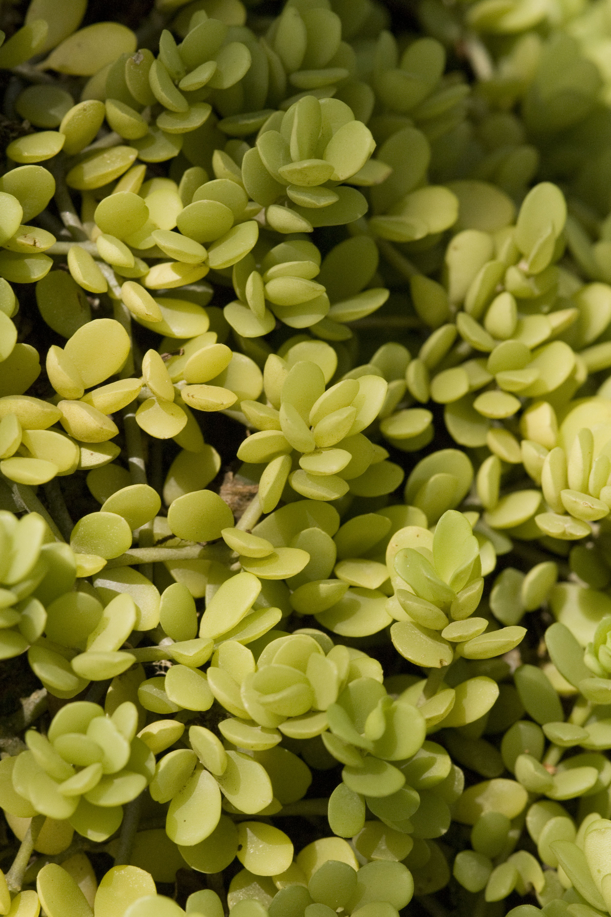 | If you look carefully, you can see that the leaves of this canopy plant have signs of succulence- literally speaking, they are full of juice. These wide fleshy leaves are adapted to hold water. This plant is exposed to a lot of wind, which has the effect of drying out the plant’s leaves. Succulence is an important strategy for these plants to survive.
LIVERWORT | ADDITIONAL INFO | OBSERVATIONS
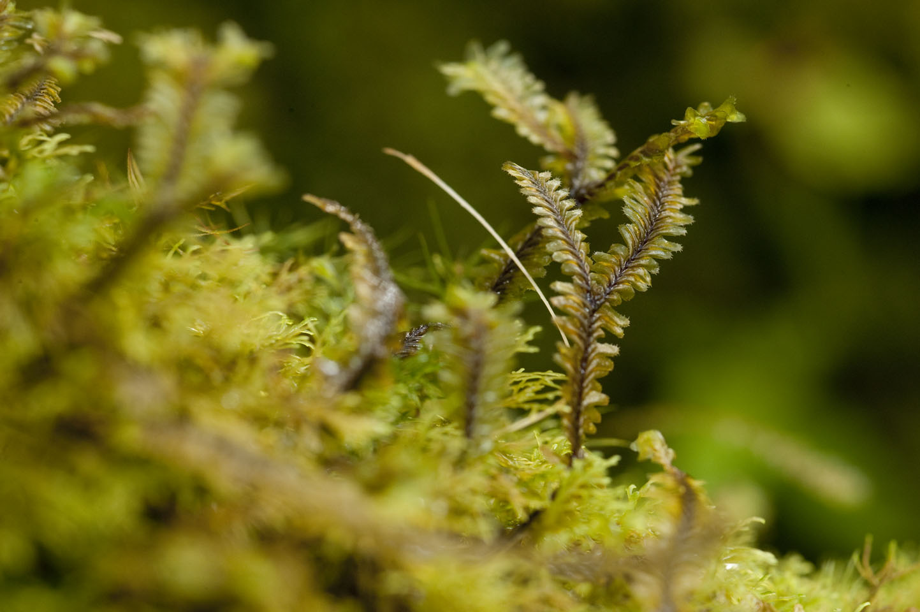 | This is a leafy liverwort, a very common group of small plants that often grow epiphytically on branches and tree trunks in very wet areas such as tropical montane cloud forests. The small branching stem you see is only about an inch, just a couple of centimeters in length.

ORGANISM ADAPTATIONS TO WATER AVAILABILITY IN THE CLOUD FOREST
Rainfall Data

Panorama #1 – Low Elevation Cloud Forest Elevation in meters: __________________

Month | Total Rainfall (mm)
September | 530.4
October | 866
November | 356
December | 80.6
January | 9.6
February | 59.8
March | 25.6
April | 1.2
May | 115.5
June | 334
July | 268.4
August | 325.5

Panorama #3 – High Elevation Cloud Forest Elevation in meters: __________________

Month | Total Rainfall (mm)
September | 671.4
October | 883.2
November | 273.4
December | 223.2
January | 78.4
February | 180.4
March | 114.8
April | 28.4
May | 248.7
June | 346.8
July | 275.9
August | 312.5

ORGANISM ADAPTATIONS TO WATER AVAILABILITY IN THE CLOUD FOREST
The Scientific Process

Scientific Question
Where does each plant species live within the cloud forest?

Hypothesis
Remember to use the form, “I predict…..because….” and support your hypothesis with information you have already gathered.

Procedure
What other information would you need in order to determine the accuracy of your hypothesis?
What other information would you need to answer the question: What adaptations does each plant species have that allow it to live in its habitat?

What processes/procedures would you utilize to get this information if you were in the cloud forest today?

Data Collection
Fill in the following chart with information you have collected from viewing the Canopy in the Clouds website. Be sure to include the panorama number and hotspot number in case you need to return to the same location.

Panorama # | Hotspot # | Data/Information Collected

Conclusion
Write a conclusion using the information you have gathered from Canopy In The Clouds media and data. Discuss whether or not your hypothesis was correct and explain the data that lead to your conclusion. The conclusion should also answer the question: What adaptations does each plant species have that allow it to live in its habitat? You should write at least two paragraphs.

ORGANISM ADAPTATIONS TO WATER AVAILABILITY IN THE CLOUD FOREST
Student Assessment

Directions: Examine the plant species that is found within the Monteverde Cloud Forest. Read the accompanying text and then answer the questions.

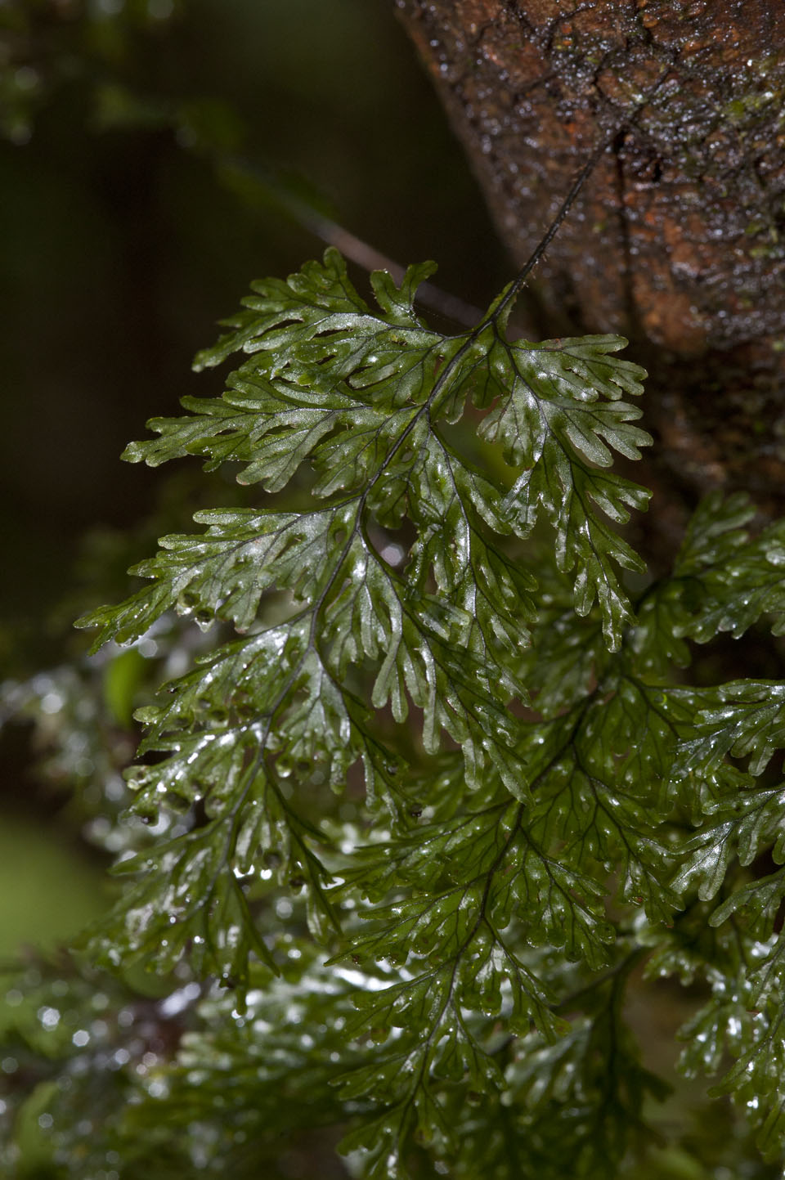 | This epiphytic plant is known as a filmy fern. The leaves often appear translucent because they may only be a single cell in thickness. This makes the fern very vulnerable to desiccation (drying out).

- Where do you believe this plant species lives within the cloud forest? You may use a panorama number, general elevation, or description of the habitat to answer the question. Be sure to include data you have collected during class to support your answers.

- What adaptations allow this plant species to live in its habitat?

